Teaching-Learning and Evaluation
Additional Information to Section 2.3.1 of SSR
Teaching Learning Process
Some of the active/participative teaching-learning techniques adopted are described below.

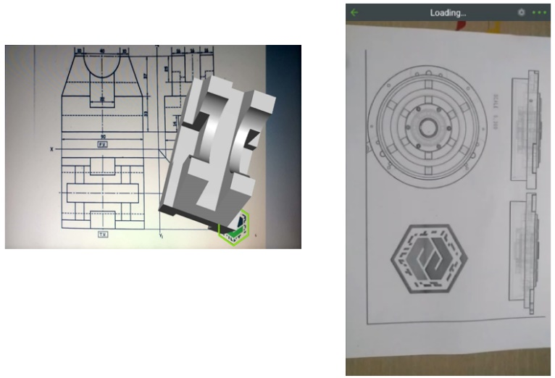
Augmented Reality App for Engineering Graphics course

Augmented reality (AR) is one of the biggest technology trends right now, and it’s only going to get bigger as AR ready smartphones and other devices become more accessible around the world
Augmented Reality being an Industry 4.0 technology, it is an great opportunity for building the next generation workforce & prepare the budding engineers industry ready for the jobs which will be offered to them in coming years. In this regard, Sardar Patel College of Engineering, (SPCE) has developed an Innovative Teaching Learning Method based on Augmented Reality (AR) which is presently a latest / emerging technology. Institute has successfully implemented this method in the First Year Curriculum for the subject of Engineering Graphics. This technique is developed with a motive of “ENGAGE & EMPOWER STUDENTS WITH AUGMENTED REALITY (AR)”.
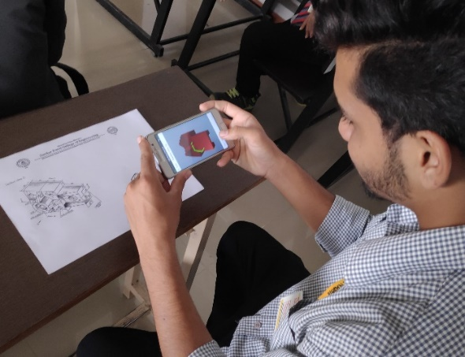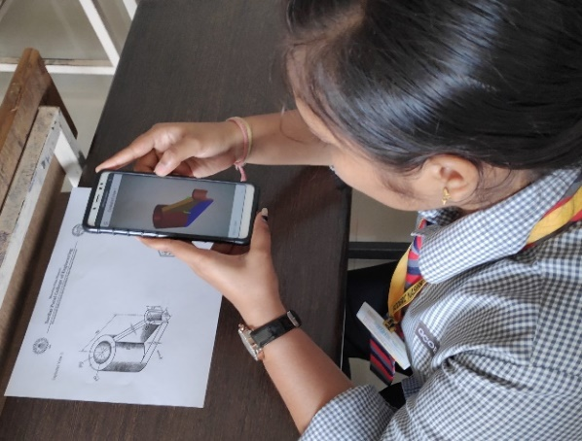
First Year students commonly have many difficulties in understanding and visualizing the shape of threedimensional (3D) objects from two-dimensional (2D) representations. In order to cater to this problem institute had developed this innovative teaching learning method using Augmented Reality Technology. Students can access 3D models from any device at any time. Whether they are at home or in the classroom, students can study and interact with the course materials.
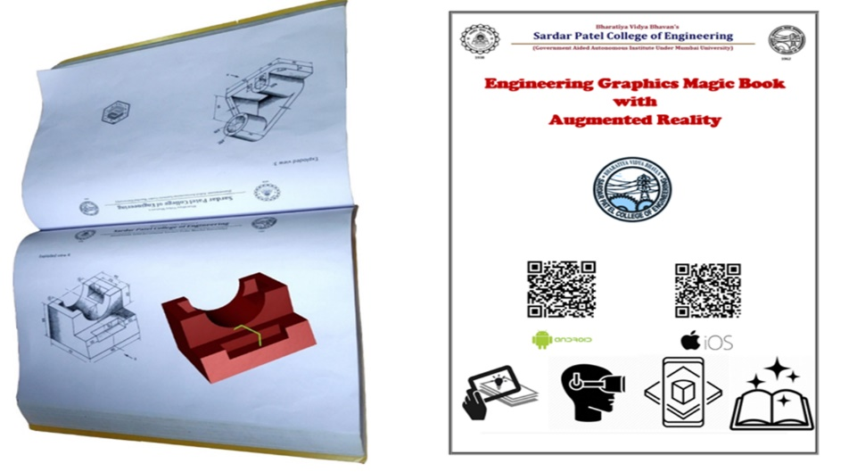
Augmented Reality enabled book was also developed for the subject of Engineering Graphics. In Teaching-Learning , AR offers the advantages like portable and less expensive learning materials, eye-catching presentations, interactive classroom lessons etc.

Mobile App for teaching Engineering Mathematics
SEAM ICT Tool SEAM ICT tool (SEAM App) is a product of SEAM eLearning, a start-up incubated at SPTBI (Sardar Patel Technological Business Incubator) SEAM is an outcome of relentless efforts of its founder, an IIT Bombay Graduate and a Professor of Mathematics at Sardar Patel College of Engineering. Being himself an engineer and professor to several engineering students, Prof Satishkumar Barot understands the challenges in Learning & Teaching Engineering Mathematics. The benefits of SEAM for students are: 1. The SEAM app helps students to practice & solve Mathematics problems Anytime & Anywhere.
2. High number of solved examples with detailed step by step solutions are available on each of the topics which helps students to understand the concepts.
3. Students can raise queries and expect answers within 24 hours.
4. Since SEAM works off-line as well, students can make use of it anytime.
The benefits of SEAM for Professors are:
1. Tailor-made content available for professors on each topic of Engineering Mathematics to prepare
2. Professors can make use of the SEAM platform to upload his/her own solutions for the benefit of students and also can edit and do corrections in real time
3. Since Students & Professors both will be using SEAM, recap of earlier lectures will happen much faster with more teaching time available
4. The SEAM content can be directly used in the classroom for teaching each topic of Mathematics as it contains lecture wise Lesson Plan with Solved Examples
5. Entire Syllabus is available, further divided in to each module wise, chapter wise and Topic wise… So you can cover everything with maximum example
The pedagogy used in SEAM app is ideal for today's generation and provides ample learning scope and flexibility to students and Professors.
In initial pilot studies, it has been observed that students who have used SEAM, have done well in their exams. SEAM has been rated at 4.7 out of 5 (Google Play Store), amongst the students and professors after using and seeing its benefits. SEAM has been liked by several students & professors who are already using in on a daily basis.
Link to Install SEAM App from Google Play Store (Android Phones) https://play.google.com/store/apps/details?id=com.primeussystems.seam Link to Install SEAM App from App Store (Apple Phones) https://apps.apple.com/in/app/seam-books/id1449640831
Alternately, visit website of SEAM Digital Flip Board

Google Classroom
‘Google Classroom’ is a service provided by Google Inc. which makes teaching more productive and meaningful by streamlining assignments, boosting collaboration, and fostering communication. Educators can create classes, distribute assignments, send feedback, and see everything in one place.
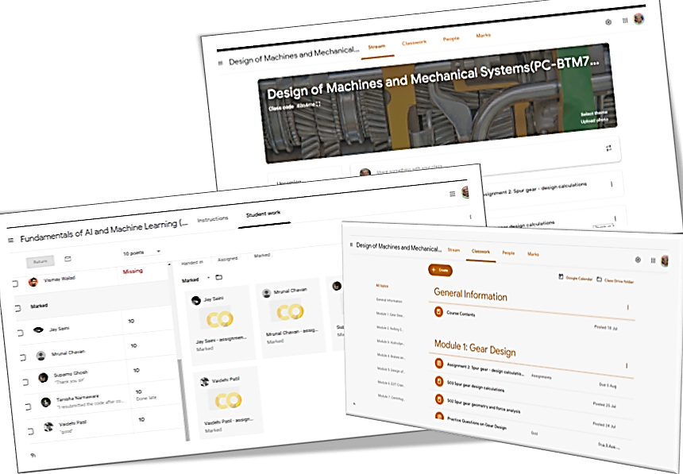
At present, this learning management system is implemented for teaching following courses.
- PC-BTM412 Kinematics of Machinery
- PC-BTM415 Solid Mechanics
- OE-BTM614 Introduction to Optimization Methods
- PC-BTM711 Design of Machines and Mechanical Systems
- PE-BTM711 Process Equipment Design and Piping Engineering
- OE-BTM718 Fundamentals of AI and Machine Learning

